

A TECHNICAL REPORT ON STUDENT INDUSTRIAL WORK
EXPERIENCE SCHEME
(SIWES)

UNDERTAKEN AT

NIGERIAN COMMUNICATIONS SATELLITE LTD,
OBASANJO SPACE CENTER,
UMARU MUSA YAR'ADUA EXPRESS WAY,
LUGBE, ABUJA,
NIGERIA.

BY

SIMON-EMIEJE OGHENEVIGHO GILBERT
21EG01014

DEPARTMENT OF COMPUTER ENGINEERING
FACULTY OF ENGINEERING
AJAYI CROWTHER UNIVERSITY

COVERING THE PERIOD FROM APRIL 2025 TO SEPTEMBER 2025.
DEDICATION

This report is dedicated to Almighty God, who has led and safeguarded me during my industrial training program.

Special dedication to my parents, Mr Simon Emieje and Mrs. Rosemary Emieje, for their unwavering love and support whose encouragement has been my greatest source of inspiration, who kept me going during my training.

I dedicate it to my departmental supervisor, Mr. Henry, for his invaluable guidance, as well as my friends and colleagues who offered their support during this journey.

ACKNOWLEDGEMENT

I wish to express my deepest gratitude to Almighty God for His strength and guidance throughout the duration of my training at NIGCOMSAT’s Innovation Department.
I extend heartfelt appreciation to Mrs. Nkechi Jane Egerton-Idehen, Managing Director/CEO of NIGCOMSAT, for providing a conducive environment for innovation and professional growth for both staff and interns.
Special thanks to Mr. Abiodun Attah, Executive Director, Technical Services, whose technical insights and leadership greatly enriched my training experience.
I am also grateful to the Corporate Affairs team for their support and for facilitating the integration of innovation initiatives within the organization.
My thanks also go to the entire staff of the Innovation Department, especially my departmental supervisors, Mr. Henry Ikechukwu Nwatu and Mrs. Maureen, for their guidance, encouragement, and collaborative spirit.

Abstract

This report summarizes the experiences and skills acquired during my Industrial Training at the Innovation Department of Nigerian Communications Satellite Limited (NIGCOMSAT), Abuja.

During the program, I participated in activities involving software development processes, research on emerging technologies, and practical demonstrations of how innovation supports satellite communication services. I also gained insights into teamwork, project documentation, and problem-solving approaches within a professional ICT environment.

The training broadened my understanding of the role of innovation in advancing communication technology and national development. Overall, it was a rewarding experience that improved my technical competence, enhanced my professional skills, and prepared me for future challenges in the ICT sector.

TABLE OF CONTENTS

Title Page …………………………………………………………..…………1

Dedication …………………………………………………………………….2

Acknowledgement ………………………………………..………………….3

Abstract…………………………………………………………………….…4

Table of contents…………………………………………….………………...5

CHAPTER ONE…………………………………………….……………..…7

INTRODUCTION………..………………………………….……..…………..7

  - Introduction ………………………………………………..…….………...7

1.2 Student Industrial Work Experience Scheme (Siwes) Background….….7

1.3 Objectives Of Siwes ………………….………………..……………….…8

1.4 Bodies Involved In The Management Of Siwes………………...……….8

1.5 Summary………………………..…………………………..…………....9

CHAPTER TWO………………………………………....................………10

BACKGROUND OF ORGANISATION ……………….…………………10

2.1 Introduction …………………..………….……………………………10

2.2 Vision and Mission………………………………...…....………………10

2.3 Structure Of The Organization ……………………….……..….…….…10

2,4 Areas of Specialization of NIGCOMSAT…………………………11

2.5 The Innovation Department……………………..……...………………12
2.6 Organogram for NIGCOMSAT………………………………..……….12
2.7 Summary …………………….……………………………………..……13

CHAPTER THREE…………………………………………………….…14

DESCRIPTION OF TRAINING ACTIVITIES……………...……….….….14

3.1 Experience Gained...……………………………….………………….…14

3.2 Full Details of Activities Filled In Logbook…………...………….…15

3.3 Skills And Knowledge Acquired………………………………..……….24

CHAPTER FOUR

4.1 PICTORIAL DOCUMENTATION…………………………………28

CHAPTER FIVE……………………………………………………….….32

SUMMARY………………………………………………………….…..…...32

5.1 Conclusion………………………………………………………...…..32

5.2 Recommendation ……………………………………………..….……33

5.3 References……………………………..……………………………..…..34

CHAPTER ONE

INTRODUCTION
  - INTRODUCTION

The Students Industries Work Experience Scheme (SIWES) is a skills
development scheme, which functions to expose and prepare students from universities and other tertiary institutions for the industrial work environment that they will most probably encounter after graduation. It is a planned and structured curriculum focused on specific professional objectives that aim to help participants develop their vocational competencies. In light of these, the SIWES programme is a graduation requirement for all Nigerian University students pursuing specific disciplines.

  - STUDENT INDUSTRIAL WORK EXPERIENCE SCHEME (SIWES) BACKGROUND

SIWES was established by a body known as the Industrial Training Fund (ITF) in 1973. The motivation behind the establishment of the scheme was the fact that employers expressed concern that graduates from Nigerian universities lacked the practical underlying experience required for employment in industries and other organizations. As a result, the employers determined that the theoretical education provided by our higher education institutions where not enough to meet the needs of labour employers. Consequently, this was the basis for establishing and developing the scheme by the Industrial Training Fund (ITF). This scheme is funded by the Federal Government and coordinated jointly by the Industrial Training Fund (ITF) and the National Universities Commission (NUC).

  - OBJECTIVES OF SIWES

Below are the objectives of SIWES;
• To establish an opportunity for students at Nigerian Universities to gain
industrial skills and experience while studying
• To prepare students for work situations they will probably encounter after graduation.
• To introduce students to work procedures and skills for handling
equipment and machines , which may not be available in their institutions.
• To make the transitions from academics to a work environment easier and facilitate the students’ connections for future career placements.
• To represent students with the avenue to apply their theoretical knowledge to practical situations, thereby closing the gap between theory and practice.

  - BODIES INVOLVED IN THE MANAGEMENT OF SIWES

Below are the bodies involved in the management of SIWES:
1. Industrial Training Fund (ITF)
2. National University Commission(NUC)
3. National Board for Technical Education (NBTE)
4. National Council for Colleges of Education (NCCE)
5. The Employers of Labour
6. Federal Government.
7. Institutions of Higher Learning

  - Summary

This programme enables students to better understand, as well as apply the theoretical knowledge obtained from their institution, through practical engagement. It has also solved a major problem of incompetence and inexperience in the industrial sector. In light to all these, its mandatory requirement is justified.

CHAPTER TWO

BACKGROUND OF ORGANISATION
2.1 INTRODUCTION
The Nigerian Communications Satellite Limited (NIGCOMSAT) is a Federal Government–owned company under the Federal Ministry of Communications, Innovation and Digital Economy. It was incorporated in April 2006 with the mandate to manage and operate Nigerian communication satellites for the provision of quality and affordable communication services.
NIGCOMSAT is responsible for the management of Nigeria’s satellites, including NigComSat-1R, which was launched in December 2011. Through satellite technology, the organization provides services such as broadband internet, Direct-to-Home (DTH) broadcasting, trunking and back-hauling services, and enterprise solutions for both public and private sectors.

2.2 Vision and Mission
• Vision: To be the leading satellite operator and service provider in Africa.
• Mission: To manage and exploit Nigeria’s satellite resources to deliver cost-effective, secure, and reliable communication solutions that drive national development.

2.3 Organizational Structure
NIGCOMSAT operates under a structured management system headed by the Managing Director/Chief Executive Officer (MD/CEO), supported by Executive Directors overseeing Technical Services, Finance, Marketing, and Innovation. The company has several departments, including Satellite Control, Technical Services, Marketing, Corporate Affairs, and Innovation.

2.4 Areas of Specialization of NIGCOMSAT
The Nigerian Communications Satellite Limited (NIGCOMSAT) specializes in the provision of satellite-based communication solutions and related services. Its core areas of specialization include:
1, Satellite Communication Services: Delivering broadband internet, direct-to-home television broadcasting, and VSAT services to organizations, institutions, and individuals across Nigeria and beyond.
2, Enterprise and Government Connectivity: Providing secure and reliable satellite communication infrastructure for government agencies, security outfits, and corporate organizations.
3, Broadband and Internet Solutions: Offering affordable satellite broadband services to underserved and rural communities, thereby bridging Nigeria’s digital divide.
4, Broadcast and Media Services: Facilitating content distribution, direct-to-home TV, and digital broadcasting for local and international media houses.
5, Navigation and Positioning (SatNav): Supporting navigation systems, including GPS augmentation services for aviation, maritime, and transportation industries.
6, Capacity Building and Training: Through its partnerships and Innovation Department, NIGCOMSAT organizes training programs, seminars, and internships to equip students and professionals with skills in ICT, satellite communication, and innovation.
7, Research and Development: Engaging in continuous research to improve satellite technologies, expand service offerings, and explore opportunities in emerging areas like space science and artificial intelligence.

2.5 The Innovation Department
The Innovation Department focuses on research, creativity, and the development of new ICT-driven solutions that leverage satellite technology. It plays a key role in driving digital transformation by:
• Exploring emerging technologies such as Artificial Intelligence (AI), Cloud Computing, and Internet of Things.
• Supporting software development projects and ICT innovations.
• Collaborating with local and international partners to develop solutions tailored to Nigeria’s socio-economic needs.
• Providing a platform for students and interns to gain hands-on experience in innovation and ICT applications.
2.6 Organogram for NIGCOMSAT

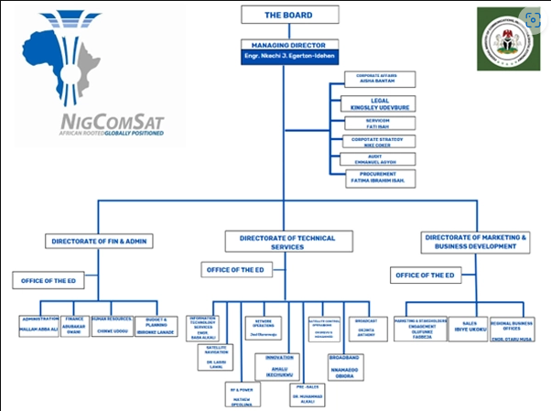

2.6 Summary
In summary, NIGCOMSAT plays a vital role in advancing Nigeria’s communication and technology landscape through the provision of satellite-based services. The organization’s structured departments and clear mission ensure the effective delivery of innovative ICT solutions that contribute to national development.
CHAPTER THREE

DESCRIPTION OF TRAINING ACTIVITIES

3.1 EXPERIENCE GAINED
During the period of my Industrial Training, I was privileged to gain valuable knowledge, practical exposure, and hands-on experience that significantly enhanced my understanding of computer engineering concepts and software development. The training period served as an avenue to bridge the gap between theory and practice, enabling me to apply classroom knowledge to real-world projects.
The experience provided me with a deep understanding of how software applications are designed, developed, tested, and deployed. I learned the importance of planning, teamwork, creativity, and logical thinking in achieving technical solutions. Throughout the training, I worked on several projects that helped me improve my technical proficiency, analytical skills, and problem-solving abilities.
One of my major achievements during the training was the development of an Artificial Intelligence assistant named Jarvis. This project helped me explore and understand the integration of various technologies such as speech recognition, text-to-speech synthesis, and automation processes. I implemented multiple functions, including news updates, weather forecasting, coding language mapping, and email sending capabilities. Through this, I gained practical experience in working with APIs (Application Programming Interfaces), handling JSON data, and building interactive systems that respond intelligently to user input. The process also improved my understanding of debugging and system optimization.
Another significant aspect of my training was learning Flutter, a cross-platform mobile application development framework. Through daily practice and mini-projects, I became proficient in the Dart programming language and gained an in-depth understanding of how Flutter widgets are used to build responsive user interfaces. I designed and implemented simple applications such as calculators, to-do lists, and quiz apps, which allowed me to learn about stateful and stateless widgets, navigation between screens, and state management. I also learned how to manage layouts, improve user experience, and implement logical operations efficiently.
Furthermore, I developed a real-time chat application that allowed users to send and receive messages instantly. This project deepened my understanding of client-server communication, authentication systems, and real-time database operations. I learned how to use authentication to secure user data, design chat interfaces, handle message synchronization, and test the app for performance and reliability. Through this process, I acquired valuable insight into how modern messaging systems work, as well as the importance of maintaining data security and privacy in user interactions.
In addition to the chat app, I created a series of utility applications, including a Notepad App, Calendar App, and Clock App. Each of these projects enhanced my understanding of application design and functionality. The Notepad app helped me learn about data persistence and CRUD (Create, Read, Update, Delete) operations, while the Calendar app strengthened my knowledge of date and time functions and event handling. The Clock app allowed me to work with timers, stopwatches, and digital clock displays, improving my ability to manipulate time-based operations in software development.
Beyond technical knowledge, my training also developed my soft skills. I learned to plan projects effectively, meet deadlines, and document progress systematically. I became more confident in presenting my work and explaining my design choices logically. The training improved my problem-solving approach, helping me break complex tasks into manageable steps and test each component efficiently.
I also gained an appreciation for version control, code readability, and collaborative development, as these are crucial practices in any professional environment. I understood the importance of writing clean and maintainable code, maintaining backups, and keeping records of system changes for future reference.
Moreover, I learned the importance of adaptability and continuous learning in the tech industry. Throughout the training, I frequently encountered new challenges that required me to research and learn independently. This improved my ability to learn new frameworks, libraries, and tools quickly and apply them effectively in my projects.
In summary, the Industrial Training period was an eye-opening experience that contributed immensely to my academic and professional growth. It gave me practical exposure to software design, implementation, and testing, while also building my confidence to take on real-world programming challenges. The skills I gained both technical and interpersonal have better prepared me for future roles in software engineering, mobile app development, and artificial intelligence.

3.2 Full Details of Activities Filled In Logbook
Week 1
Monday - Today I was shown to my department and was introduced to my Co-worker and Supervisor
Tuesday - Today I explored the Nigcomsat building and discover other department and offices
Wednesday - didn’t go to work
Thursday - didn’t go to work
Friday - didn’t go to work
Unit - Innovation
Weeek 2
Monday - Today I was given a task to create an Intern-management-system(login page, sign-up page, dashboard and application page.)
Tuesday - Today I worked on the login and sign-up page using HTML and CSS
Wednesday - Today I worked on the Dashboard page using HTML and CSS
Thursday - Today I worked on the Application page
Friday - Today I improved my HTML and CSS by creating a 3d website project that go on a circular motion displaying the images
Week 3
Monday - Today I started learning JAVASCRIPT (The basic) so I can improved my front-end skills
Tuesday - Today I created a portfolio using HTML, CSS and JAVASCRIPT
Wednesday - Today I add JAVASCRIPT codes into the intern-management system
Thursday - didn’t go to work
Friday - public hoilday
Week 4
Monday - public hoilday
Tuesday - Today me and the team gather for a meeting about the intern-management system flow-chat
Wednesday - Today me and the team had a meeting with the MD(managing director) of NIGCOMSAT and explain the purpose of the intern-management system
Thursday - Today I created a speech to text program using python
Friday - Today I created a cinematic website to improved my HTML, CSS and JAVASCRIPT skills
Week 5
Monday - Today I watched a video on how to make an AI assistant using python
Tuesday - I Created my own AI assistant giving it this functions (text to speech, open some of my application in the system).
Wednesday - Today I learned REACT JS and TAILWIND CSS (the basic)
Thursday - Today I add new functions to my AI (speech recognition, search on Wikipedia, Google and YouTube)
Friday - didn’t go to work
Week 6
Monday - Today I gave my AI a name (JARVIS) and a greeting function
Tuesday - I add (send email, get news and weather forecast) functions to my AI
Wednesday - Today I gave my AI a language map function
Thursday - Today I created a portfolio using REACT JS
Friday - Today I download some coding tutorial videos on REACT and TAILWIND CSS
Week 7
Monday - Today I deleted my AI project because it was corrupted so I started from the beginning
Tuesday - Set up project environment for building an AI assistant (named CLONE). Installed Python libraries and created the base structure.
Wednesday - Researched different text-to-speech (TTS) libraries like pyttsx3 and GTTS.Compared online vs offline performance.
Thursday - Installed and tested pyttsx3. Configured the voice output and adjusted speech rate.
Friday - Created basic input/output system for Jarvis to take commands and give spoken responses.
Week 8
Monday- Worked on error handling for TTS module. Tested with different sample texts.
Tuesday - I Reviewed Google Search API and web scraping options and tested with sample queries.
Wednesday - I Researched methods for mapping coding languages to provide syntax help.
Thursday - I Designed coding language map module (basic syntax examples for Python, Java, and C++).
Friday – Conducted tests on TTS + search + coding language map together.
Week 9
Monday - Started email function design using SMTP protocol and Configured SMTP for Gmail and tested sending emails from clone.
Tuesday - Implemented app-specific password authentication for email function.
Wednesday- I Researched APIs for news integration. Selected NewsAPI for real-time updates.
Thursday - I Implemented news fetching module and tested fetching top headlines for a country(Nigeria).
Friday - Tested all modules together (TTS, search, coding map, email, news).
Week 10
Monday - Started weather forecast function research. Registered on OpenWeatherMap API.
Tuesday - Integrated weather API into Clone and displayed basic forecasts.
Wednesday - I Added error handling for API failures and invalid city names.
Thursday - I Refined assistant workflow to ensure all functions are well integrated.
Friday - I Tested email + news + weather modules together and did a final test.
Week 11
Monday - Installed Flutter SDK and set up environment on Android Studio/VS Code. Configured emulator.
Tuesday - Learned Flutter basics – widgets, hot reload, and project structure.
Wednesday - Practiced building a simple “Hello World” app with custom text styling.
Thursday - Studied layout widgets: Column, Row, Container. Created sample UIs.
Friday - Implemented a simple counter app using StatefulWidget.
Week 12
Monday - I Learned navigation in Flutter (routes, Navigator.push). Built a 2-page app.
Tuesday - I Practiced input forms with TextField and buttons.
Wednesday - I Explored images and assets in Flutter projects.
Thursday - I Built a small profile card app with image + text + icons.
Friday - I Debugged layout issues and improved UI design.
Week 13
Monday - I Learned about ListView and GridView for displaying lists.
Tuesday - I tried to run my flutter app on my phone and I met ED(Executive Directors)
Wednesday - I check my AI for any errors and debug it
Thursday - Learned about Flutter packages and installed third-party libraries.
Friday - didn’t go to work today
Week 14
Monday - I Integrated a simple HTTP request (fetching dummy API data).
Tuesday - Today I test and improved the flutter app.
Wednesday - Today I Learned about state management concepts (setState, basics of Provider).
Thursday - I Explored Flutter themes (colors, fonts, dark mode).
Friday - I Finalized simple Flutter projects and documented learning's.
Week 15
Monday - I Planned the chat app features send/receive messages.
Tuesday - I Designed the app interface (chat bubbles, input field, send button, login/register pages).
Wednesday - Implemented UI layout for chat screen using Flutter.
Thursday - I Added functionality for sending messages (messages display instantly in the chat area).
Friday - I research on real-time messaging options (firebase, websocket)
Week 16
Monday - I Created Firebase project and linked to chat app.
Tuesday - I Designed login and register pages in Flutter.
Wednesday - I Integrated Firebase Authentication for signup (email + password).
Thursday - I Implemented user login and logout functions.
Friday - I Tested login/register workflow with multiple accounts.

Week 17
Monday - I Linked authenticated users to their unique chat history.
Tuesday - I Implemented message sending to Firebase for each logged-in user.
Wednesday - I Implemented message retrieval (real-time updates for signed-in users).
Thursday - I Debugged authentication + messaging conflicts.
Friday - I improved UI with timestamps for each messages.
Week 18
Monday - I Added message status (sent/delivered).
Tuesday - I Refined login/register pages with input validation.
Wednesday - I Debugged login errors and optimized Firebase queries.
Thursday - I Final test of login → send/receive messages → logout flow.
Friday - I did a Final review, polished UI, and wrapped up chat app project.
Week 19
Monday - I Planned Notepad app features – create, edit, save, and delete notes.
Tuesday - I Designed UI for notes list and note editor page.
Wednesday - I Implemented basic note creation and saving in local storage.
Thursday - I Added note editing functionality.
Friday - I Implemented delete function for notes and Worked on UI improvements for better note display.
Week 20
Monday - I Debugged storage issues with multiple notes.
Tuesday - I Added search feature to quickly find notes.
Wednesday - I Implemented sorting by date and title.
Thursday - I Tested note app with sample data and Fixed UI responsiveness issues.
Friday - I Completed documentation for Notepad app.
Week 21
Monday - I Designed calendar grid UI and Implemented date selection and Implemented date selection and display
Tuesday - I Added event creation and display and Debugged event saving issues.
Wednesday - I Improved calendar navigation (next/previous month).
Thursday - I Added reminders/notifications for events.
Friday - I did a Final testing on the Calendar app.
Week 22
Monday - I Started Clock app project (planned features: digital clock, alarm, stopwatch).
Tuesday - I Designed clock UI and Implemented real-time digital clock.
Wednesday - I Added alarm functionality and Implemented stopwatch feature.
Thursday - I Integrated alarm sound and snooze option.
Friday - I Debugged time synchronization issues.
Week 23
Monday - I Polished UI for clock, alarm, and stopwatch.
Tuesday - I Conducted full testing of Calendar + Clock apps.
Wednesday - I Documented project features and functions.
Thursday - I Finalized apps and prepared demo presentation.
Friday - I didn’t come to work
Week 24
Monday - I Planned calculator app features basic arithmetic operations (addition, subtraction, multiplication, division). Created project setup and initial UI design.
Tuesday - I Implemented number buttons (0–9) and display screen. Added input functionality for numbers.
Wednesday - I Developed addition and subtraction functions. Linked buttons to operations.
Thursday - I Completed multiplication and division functions. Handled division by zero errors.
Friday - I testing of all functions and fixed minor bugs.

3.3 SKILLS AND KNOWLEDGE ACQUIRED
Throughout the period of my Industrial Training, I was able to acquire valuable skills and knowledge that broadened my understanding of software development, artificial intelligence, and computer engineering principles. The training period provided me with an opportunity to apply the theories learned in school to real-world projects while gaining practical experience with modern technologies and tools.

1. Programming and Software Development Skills
One of the most significant areas of growth during my Industrial Training was in programming. I became proficient in several programming languages such as Python, Dart, Java, and JavaScript, which I used to build both desktop and mobile applications. I learned how to write efficient, modular, and readable code while following proper programming conventions and design principles.
Working on various projects helped me understand the complete software development life-cycle from planning, design, and implementation to testing and deployment. I also gained experience in handling real-world programming challenges such as debugging errors, handling exceptions, and optimizing code for performance.
Through the development of my Jarvis AI assistant, I learned how to integrate multiple technologies into one system and make different modules communicate seamlessly. This greatly improved my understanding of how complex systems operate and how software components can be structured for scalability and maintainability.

2. Mobile Application Development
During the training, I gained strong competence in mobile app development using the Flutter framework and Dart programming language. Flutter provided a versatile environment for creating cross-platform applications that run smoothly on both Android and iOS devices.
I learned how to design intuitive user interfaces using Flutter’s widget system, manage navigation between multiple screens, and implement state management for dynamic user interaction. I worked on several mini-projects, including a calculator app, notepad app, calendar app, clock app, and chat application, all of which helped me understand the practical aspects of front-end development, app logic, and user experience design.
These projects also exposed me to Firebase for real-time database storage, authentication systems, and data synchronization, which are essential components of modern mobile applications.

3. Artificial Intelligence and Automation
Another major area of knowledge gained was in Artificial Intelligence (AI) and automation systems. Developing my personal AI assistant, Jarvis, allowed me to explore the use of APIs, speech recognition, text-to-speech engines, and data automation.
I implemented features such as voice responses, coding language mapping, email automation, real-time news and weather updates, and internet search. This project helped me understand how to make an AI system interact intelligently with users by processing inputs and delivering accurate outputs.
I also learned how to handle natural language processing tasks and integrate external APIs to extend an AI system’s capability, which is a valuable skill in today’s world of intelligent software systems.

4. Database Management and Data Handling
The training improved my understanding of database management systems and data flow in application development. Through the chat and notepad applications, I learned how to store, retrieve, and update user data efficiently while maintaining data security and privacy.
I gained practical knowledge in managing structured and unstructured data using tools such as Firebase and local storage systems. I also learned how to synchronize real-time messages between users, store note entries persistently, and ensure proper data backup and retrieval mechanisms.
This helped me understand the importance of data integrity, consistency, and security in modern application development.

5. Software Tools and Development Technologies
Throughout the training period, I worked with several essential tools and technologies used in professional software development environments. I became familiar with Visual Studio Code, Android Studio, and Firebase Console for app creation, debugging, and testing.
I also learned how to use Git and GitHub for version control, which allowed me to manage code updates, track changes, and collaborate efficiently. These tools taught me industry-standard practices for maintaining project integrity and documentation.
In addition, I learned how to test and debug applications using built-in development tools and simulators, ensuring that my apps performed efficiently on different devices and platforms.

6. Problem-Solving and Logical Reasoning
One of the most valuable aspects of my Industrial Training was the development of my problem-solving and critical thinking abilities. I encountered several challenges while building and testing applications, including logic errors, integration failures, and compatibility issues.
Each challenge gave me the opportunity to research, analyze the problem, and apply logical reasoning to find an effective solution. I learned that problem-solving is not only about fixing bugs but also about understanding user needs, predicting potential issues, and designing software that prevents errors before they occur.
This experience improved my analytical skills and gave me confidence in handling more complex projects independently.

7. Project Management and Documentation
Through the entire training period, I also gained knowledge in project planning, time management, and documentation. I learned to plan each project by breaking tasks into smaller, achievable goals, which improved my productivity and efficiency.
I documented my progress weekly in a logbook and created reports detailing the objectives, implementation process, and challenges faced in each project. This enhanced my ability to communicate technical processes in a clear and professional manner.
The experience taught me how to balance multiple projects and maintain steady progress within deadlines, an essential skill for future career success.

8. Communication and Professional Development
Beyond technical skills, I developed strong communication and interpersonal abilities. I learned how to discuss technical ideas, receive feedback, and collaborate effectively with supervisors and peers.
This improved my confidence in presenting projects, explaining technical concepts clearly, and participating in team-based development. I also learned the importance of discipline, professionalism, and consistent learning in achieving success in the tech industry.

CHAPTER FOUR

4.1 PICTORIAL DOCUMENTATION
This chapter contains photographs taken during the Industrial Training program. The pictures show various stages of work, application development, and participation in technical activities. Each photograph is accompanied by a short description for clarity.

AI Assistant (Jarvis) Interface
Description: The interface of the AI-powered personal assistant “Jarvis” developed using Python. It includes features such as speech recognition, email automation, and weather forecast display.
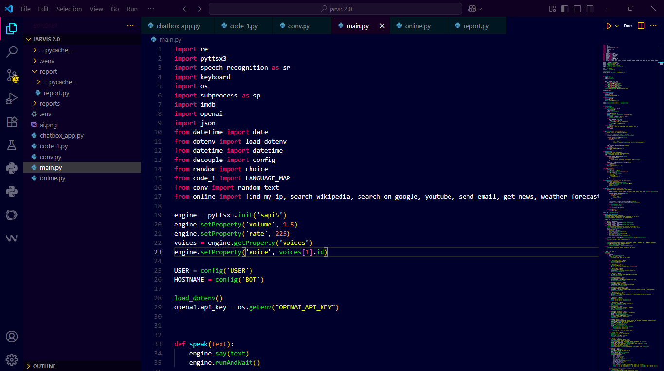

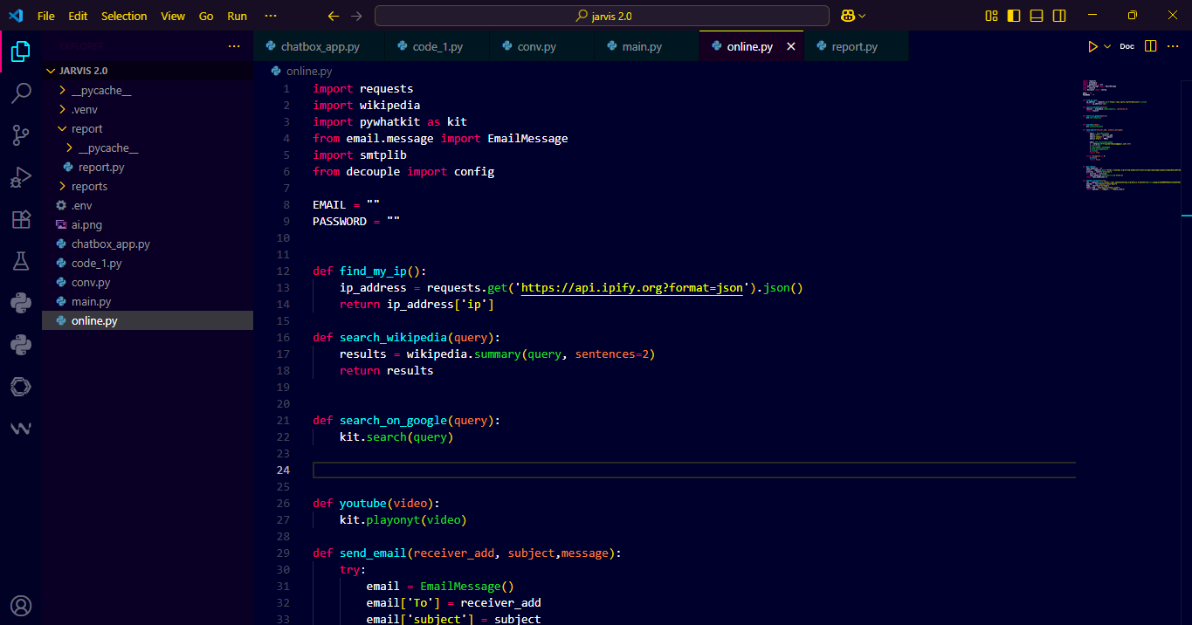

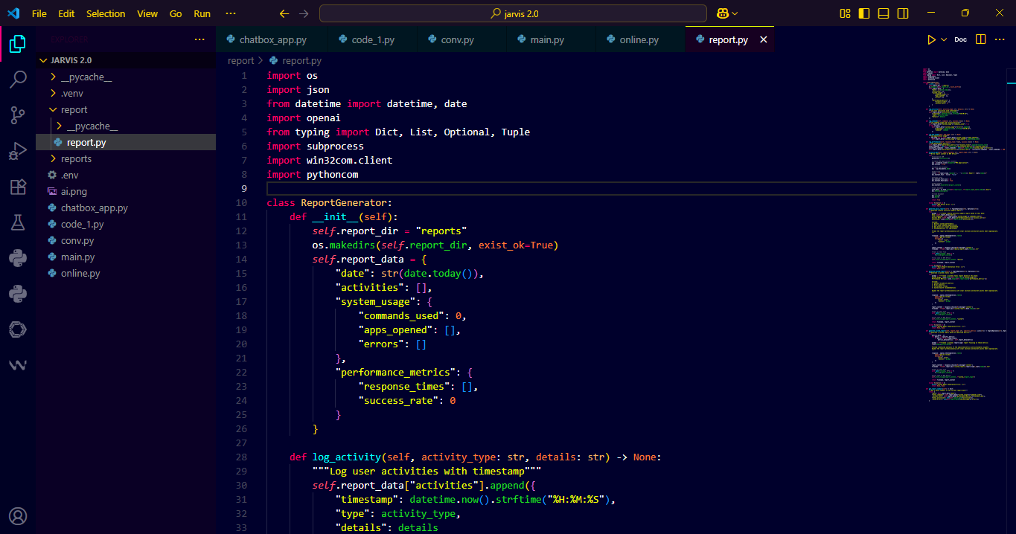

Notepad App
Screenshot of the notepad application code. The app allows users to create, save, edit, and delete notes.
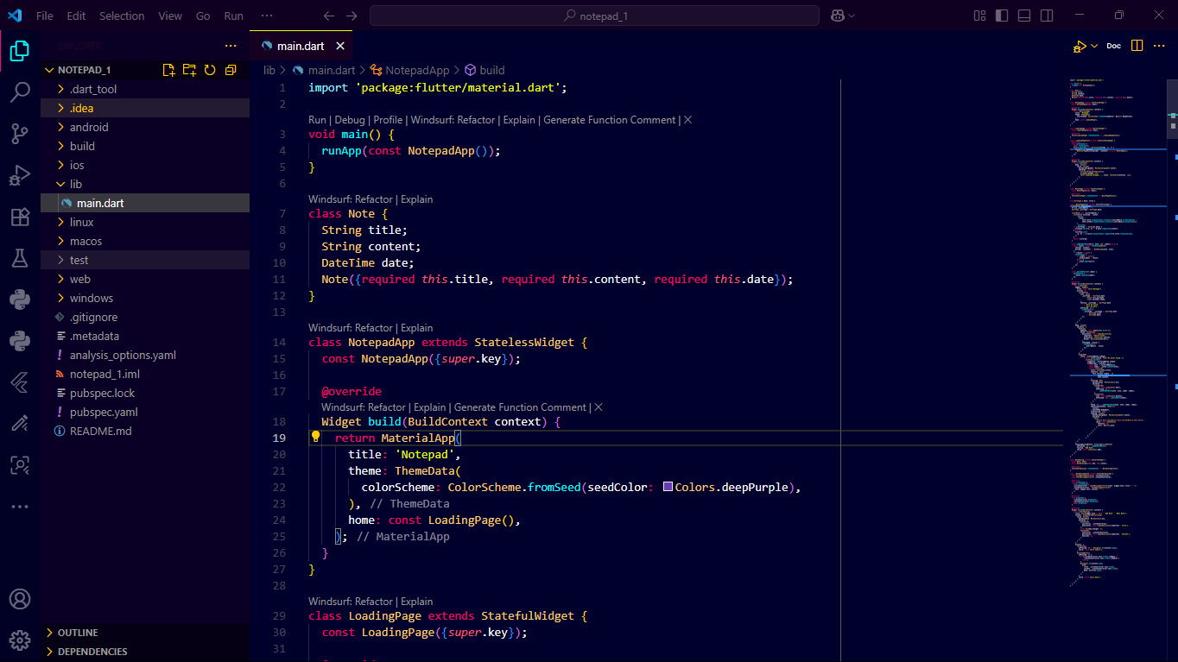
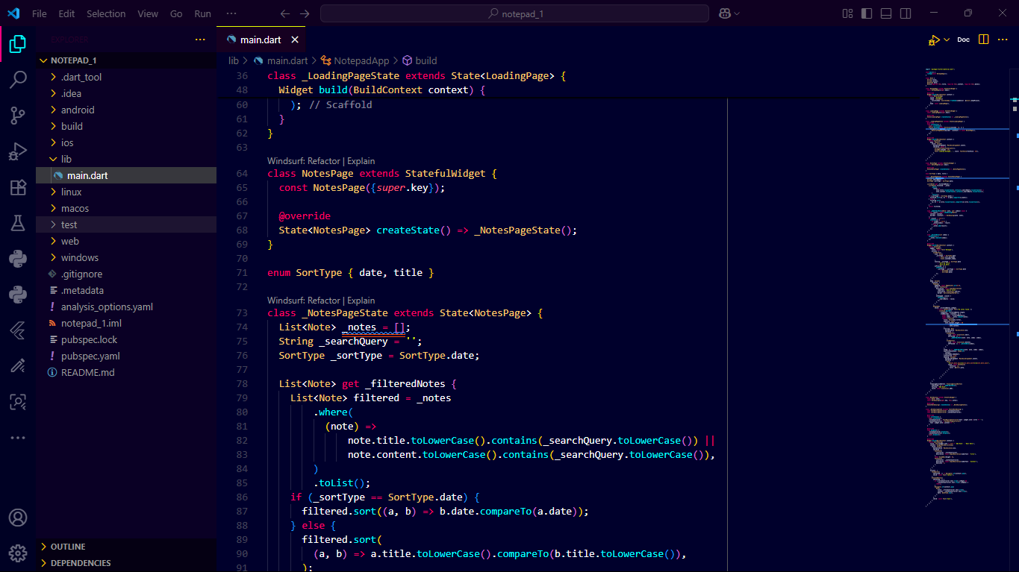

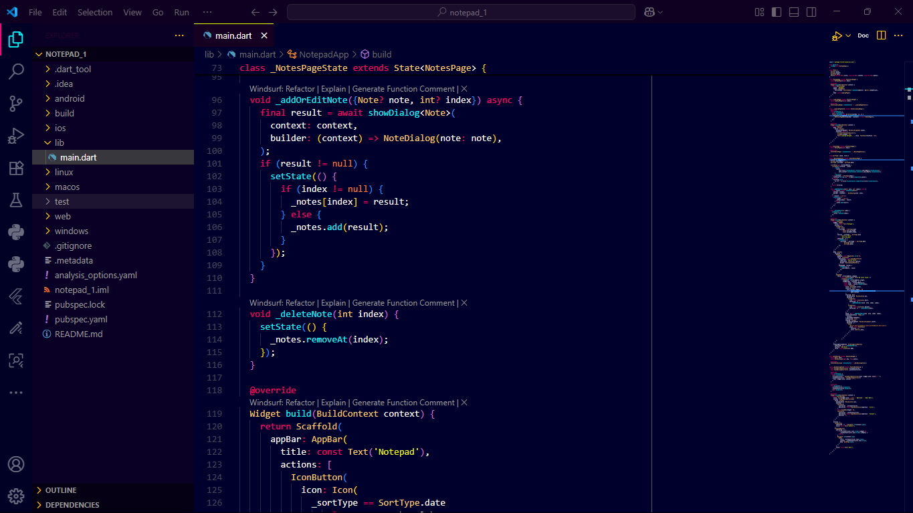

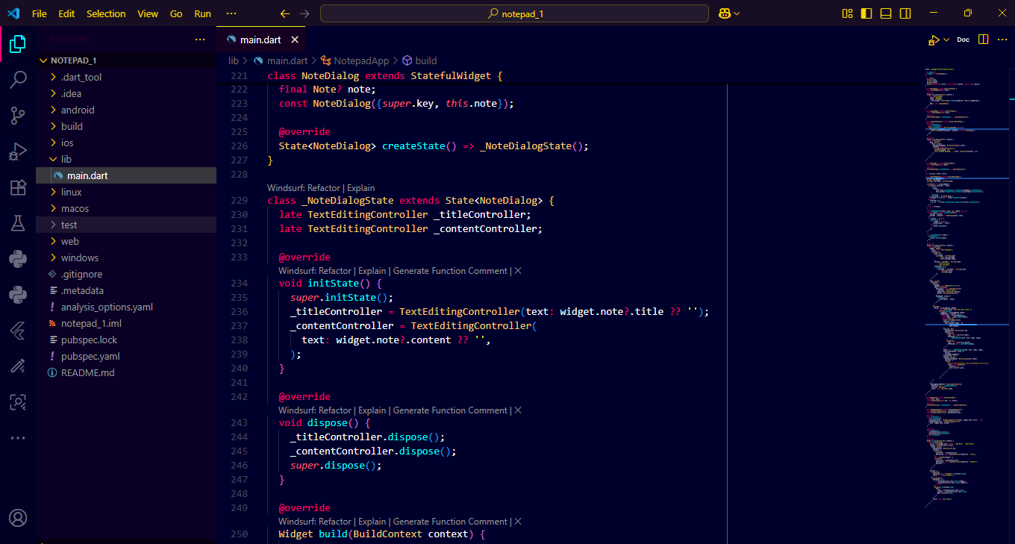

CHAPTER FIVE

SUMMARY

5.1 Conclusion
This six-month Industrial Training program provided me with a rare and valuable opportunity to bridge the gap between theoretical classroom learning and practical, real-world application. During this period, I gained extensive knowledge, hands-on experience, and professional exposure in software development, artificial intelligence, and mobile application design.
The training enabled me to apply core principles of computer engineering to solve real-life problems through the design and development of innovative software systems. My activities were centered around developing functional and user-friendly applications, improving my programming proficiency, and enhancing my understanding of system design, logic formulation, and user interface development.
In the first phase of my training, I focused on creating an Artificial Intelligence Assistant named “Jarvis.” This project introduced me to the integration of multiple technologies such as speech recognition, text-to-speech synthesis, automated email sending, real-time weather forecasting, and news retrieval. Through this, I gained practical experience in API integration, voice-based automation, and multi-functional program design. It strengthened my skills in Python and taught me the importance of modular coding and performance optimization.
The second phase involved learning Flutter, a cross-platform framework that uses the Dart programming language. I dedicated time to understanding the architecture of Flutter, working with widgets, and building several small but meaningful projects such as a calculator, to-do list, and quiz app. This phase helped me master the art of developing user interfaces that are responsive, interactive, and aesthetically appealing.
In the third phase, I developed a real-time chat application that allowed users to register, log in, send, and receive messages. This project deepened my understanding of authentication systems, database management, and real-time data synchronization. I also gained knowledge of Firebase integration, message storage, and user data protection, which are crucial in secure application development.
The final stages of my training focused on creating practical utility applications a Notepad, Calendar, and Clock app each designed to solve everyday problems. Through these projects, I learned how to implement CRUD operations, manage persistent data, and work with time-based functionalities in application development. These experiences strengthened my programming logic, debugging skills, and attention to detail.
Beyond technical proficiency, the Industrial Training also helped me develop essential professional skills such as time management, documentation, communication, and teamwork. I learned to plan projects systematically, work under minimal supervision, and meet set deadlines. I also developed the ability to troubleshoot effectively and document my work clearly for future reference.
Overall, the Industrial Training program was a deeply enriching experience that contributed immensely to my personal and professional growth. It provided me with practical exposure to the software development process from planning and implementation to testing and deployment. The knowledge and experience gained have strengthened my confidence, improved my problem-solving skills, and prepared me to take on greater challenges in the field of computer engineering and technology.

5.2 Recommendation
Based on my experience, I would like to make the following recommendations:
• For NIGCOMSAT It would be beneficial to provide interns with structured on-boarding and clearer orientation at the beginning of the training. This will enable them to settle in faster and become more productive. Also, providing adequate technical resources and guidance will improve the quality of learning.
• Interns should cultivate a spirit of teamwork, self-learning, and adaptability. They should also explore beyond their assigned tasks to gain a broader understanding of the organization’s operations.
Allowances should be paid to students like NYSC corp members and not after
• Schools should continue to encourage industrial training programs, as they serve as a bridge between classroom knowledge and real-world applications.

5.3 References
• NIGCOMSAT Official Website: https://nigcomsat.gov.ng
• Online tutorials and courses: https://www.w3schools.com, www.youtube.com
• https://github.com
• Personal notes and project files during industrial training

